**Results**

1. **Logistic Regression:**

| Algorithm used/Parameters used | Logistic Regression |
| --- | --- |
| Accuracy | 0.87 |
| Precision | 0.87 |
| Recall | 0.87 |
| F-measure | 0.87 |
| MCC | 0.73 |
| ROC | 0.86 |
| PRC | 0.9 |

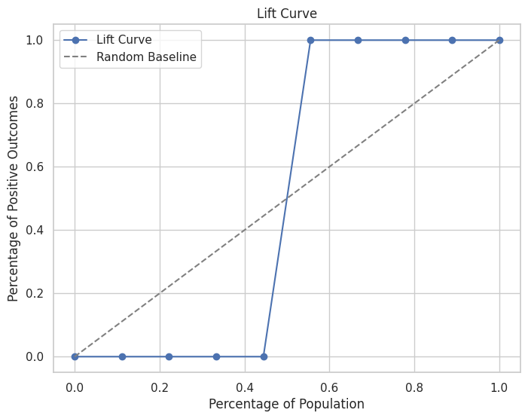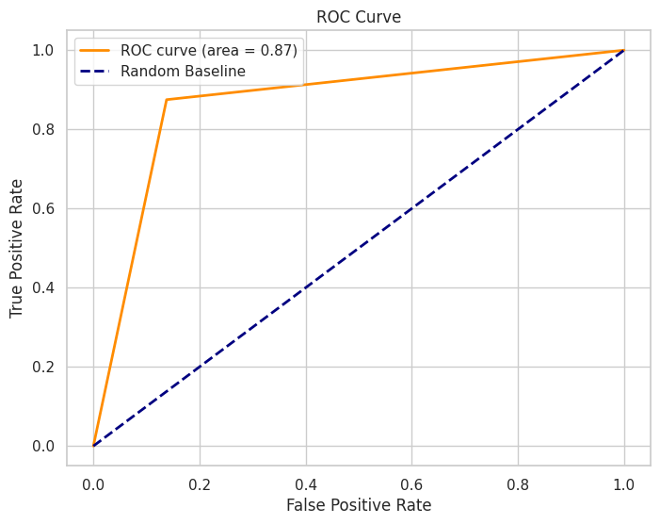

Best Parameters: {'C': 100, 'penalty': 'l2'}

1. **Random Forest Regression:**

| Algorithm used/Parameters used | Random Forest Algorithm |
| --- | --- |
| Accuracy | 0.81 |
| Precision | 0.83 |
| Recall | 0.82 |
| F-measure | 0.82 |
| MCC | 0.65 |
| ROC | 0.82 |
| PRC | 0.88 |

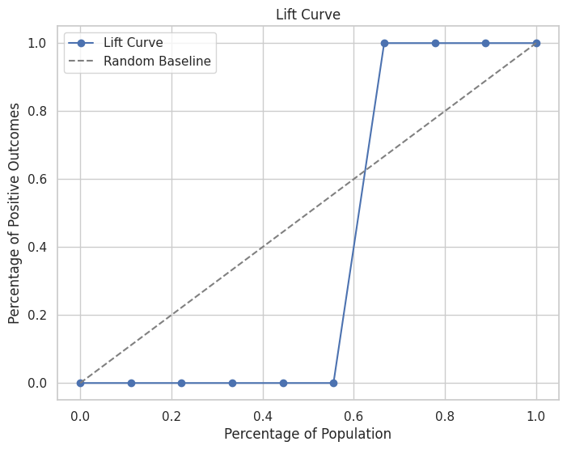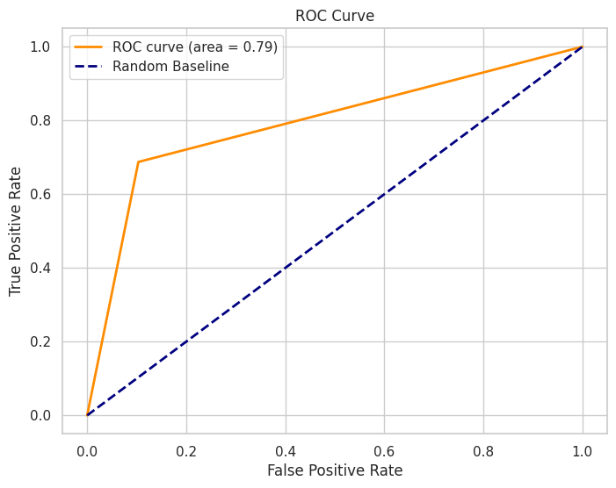

Best Parameters: {'bootstrap': True, 'class_weight': 'balanced', 'criterion': 'gini', 'max_depth': None, 'max_features': 'sqrt', 'min_samples_leaf': 4, 'min_samples_split': 2, 'n_estimators': 120, 'verbose': 0}

1. **Decision Tree Algorithm:**

| Algorithm used/Parameters used | Decision Tree |
| --- | --- |
| Accuracy | 0.75 |
| Precision | 0.78 |
| Recall | 0.75 |
| F-measure | 0.75 |
| MCC | 0.53 |
| ROC | 0.76 |
| PRC | 0.84 |

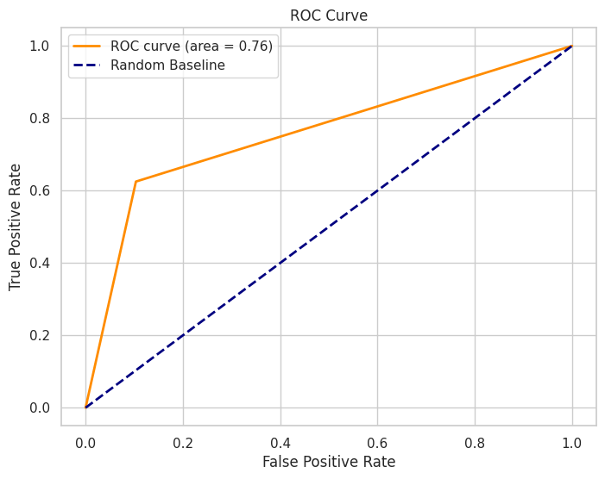

Best Parameters: {'class_weight': None, 'criterion': 'gini', 'max_depth': None, 'max_features': 'sqrt', 'min_samples_leaf': 2, 'min_samples_split': 2}

1. **K Nearest Neighbour:**

| Algorithm used/Parameters used | KNN |
| --- | --- |
| Accuracy | 0.84 |
| Precision | 0.79 |
| Recall | 0.9 |
| F-measure | 0.84 |
| MCC | 0.68 |
| ROC | 0.84 |
| PRC | 0.9 |

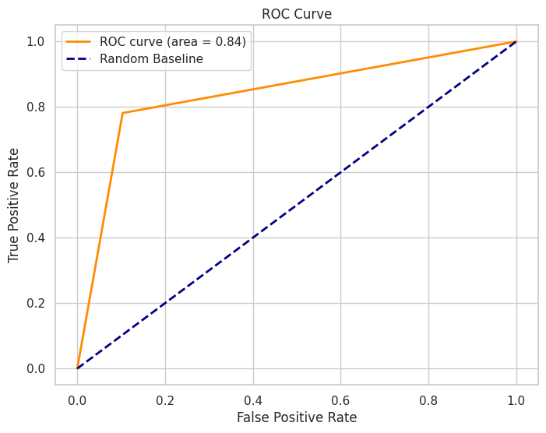

Best k = 7

1. **AdaBoost (Decision Tree and Adaboost Classifier)**

| Algorithm used/Parameters used | AdaBoost |
| --- | --- |
| Accuracy | 0.82 |
| Precision | 0.8 |
| Recall | 0.83 |
| F-measure | 0.81 |
| MCC | 0.64 |
| ROC | 0.82 |
| PRC | 0.88 |

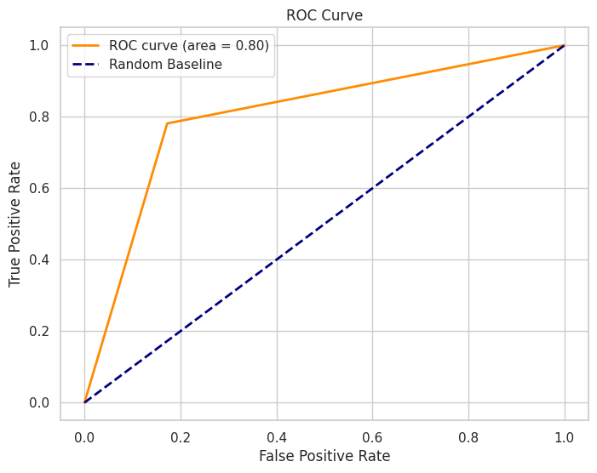

Best Parameters: {'learning_rate': 0.01, 'n_estimators': 50}

1. **Naive Bayes Algorithm:**

| Algorithm used/Parameters used | Naive Bayes |
| --- | --- |
| Accuracy | 0.54 |
| Precision | 0.51 |
| Recall | 0.93 |
| F-measure | 0.66 |
| MCC | 0.17 |
| ROC | 0.55 |
| PRC | 0.68 |

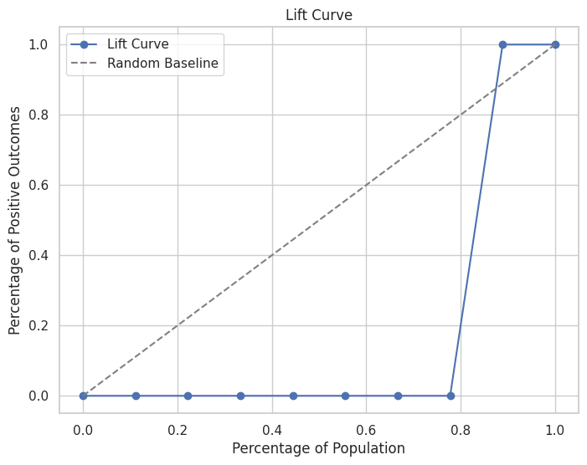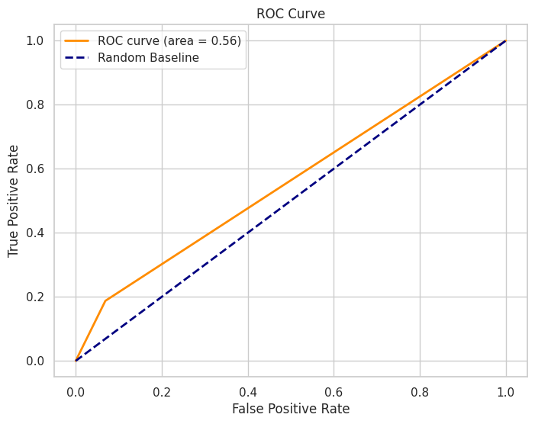

1. **Linear Discriminant Analysis:**

| Algorithm used/Parameters used | Linear DIscriminant Analysis |
| --- | --- |
| Accuracy | 0.87 |
| Precision | 0.84 |
| Recall | 0.9 |
| F-measure | 0.87 |
| MCC | 0.74 |
| ROC | 0.87 |
| PRC | 0.91 |

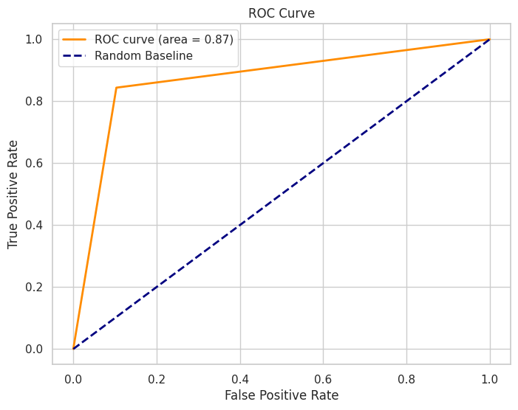

1. **Deep Neural Network:**

Layers: [inputs,3,4,output]

| Algorithm used/Parameters used | Deep Neural Network |
| --- | --- |
| Accuracy | 0.48 |
| Precision | 0.48 |
| Recall | 0.1 |
| F-measure | 0.64 |
| MCC | 0 |
| ROC | 0.5 |
| PRC | 0.76 |

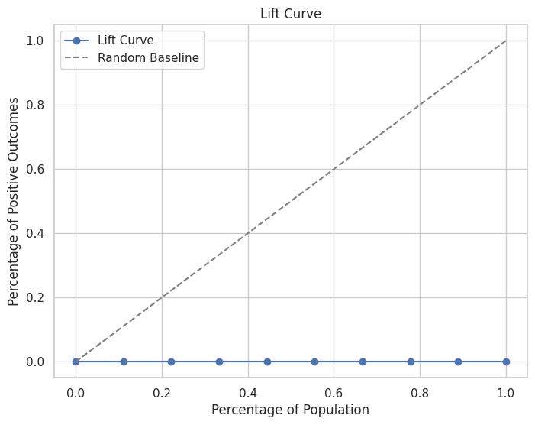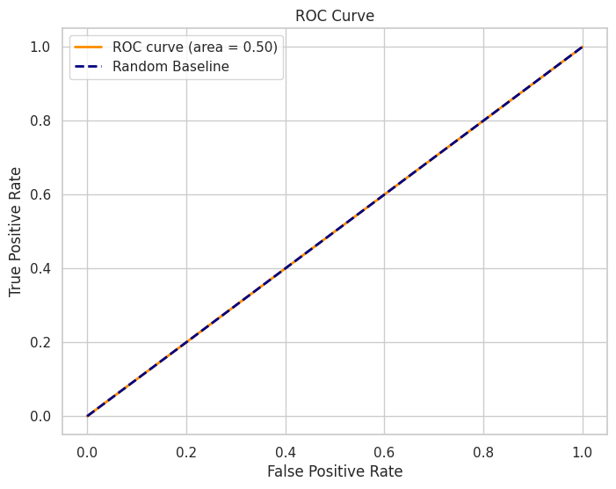

**Conclusion:**

| Algorithm used/Parameters used | Logistic Regression | Random Forest Algorithm | Decision Tree | KNN | AdaBoost | Naive Bayes | Linear Discriminant Analysis | Deep Neural Network |
| --- | --- | --- | --- | --- | --- | --- | --- | --- |
| Accuracy | 0.87 | 0.81 | 0.75 | 0.84 | 0.82 | 0.54 | 0.87 | 0.48 |
| Precision | 0.87 | 0.83 | 0.78 | 0.79 | 0.8 | 0.51 | 0.84 | 0.48 |
| Recall | 0.87 | 0.82 | 0.75 | 0.9 | 0.83 | 0.93 | 0.9 | 0.1 |
| F-measure | 0.87 | 0.82 | 0.75 | 0.84 | 0.81 | 0.66 | 0.87 | 0.64 |
| MCC | 0.73 | 0.65 | 0.53 | 0.68 | 0.64 | 0.17 | 0.74 | 0 |
| ROC | 0.86 | 0.82 | 0.76 | 0.84 | 0.82 | 0.55 | 0.87 | 0.5 |
| PRC | 0.9 | 0.88 | 0.84 | 0.9 | 0.88 | 0.68 | 0.91 | 0.76 |